North Hollywood West Neighborhood Council
Special Board Meeting
Wednesday;June 29th, 2016 Promptly at 06:30pm
Valley Plaza Recreation Child Care Center
6451 Saint Clair Avenue(Next to Tennis Courts), North Hollywood, CA 91605
____________________________________________________________
The public is requested to fill out a “Speaker Card” to address the Board on any item of the agenda prior to the Board taking action on an item. Comments from the public on agenda items will be heard only when the respective item is being considered. Comments from the public on other matters not appearing on the agenda that are within the Board’s subject matter jurisdiction will be heard during the Public Comment period. Public comment is limited to 3 minutes per speaker, unless waived by the presiding officer of the Board. Agendas are posted for public review at: Saticoy Elementary School, 7850 Ethel Avenue, North Hollywood. In compliance with Government Code section 54957.5, non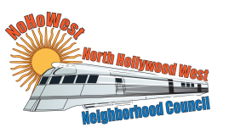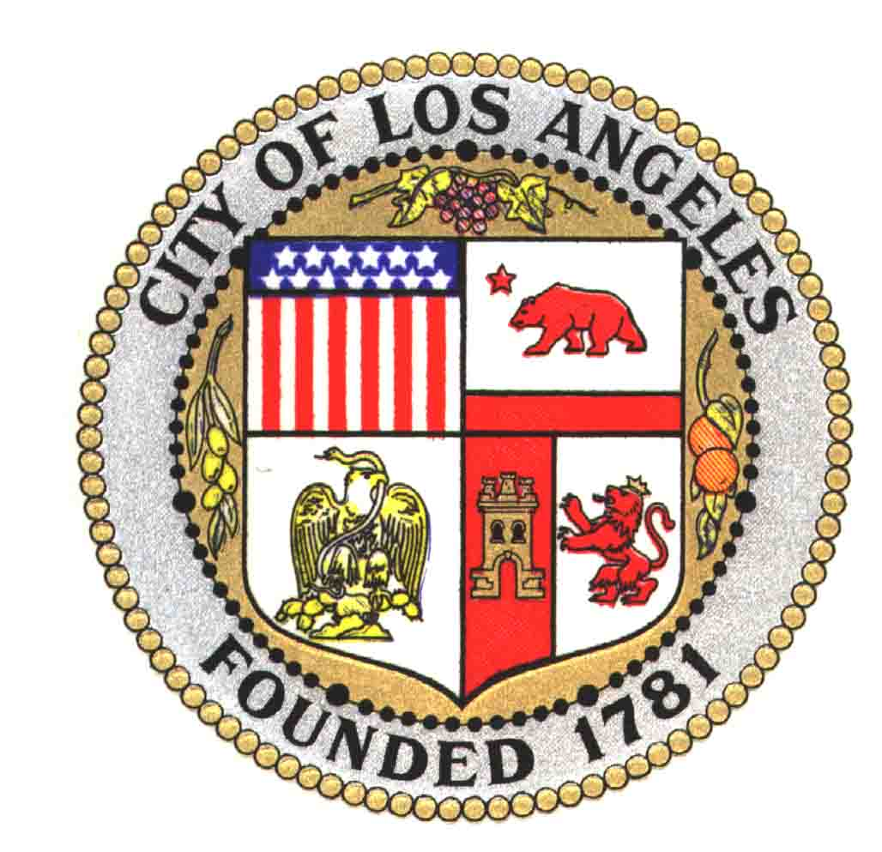-exempt writings that are distributed to a majority or all of the board in advance of a meeting, may be viewed at the scheduled meeting.
As a covered entity under Title II of the Americans with Disabilities Act, the City of Los Angeles does not discriminate on the basis of disability and upon request, will provide reasonable accommodation to ensure equal access to its programs, services and activities. Sign language interpreters, assistive listening devices, or other auxiliary aids and/or services may be provided upon request. To ensure the availability of services, please make your request at least 3 business days (72 hours) prior to the meeting you wish to attend by contacting the Department of Neighborhood Empowerment at (818 762-5866 or by e-mailing NCSupport@lacity.org.
Did you know? You can call 3-1-1 to be connected to any City of Los Angeles service. Use it to report graffiti, arrange for bulky item pick up, or reach any City Department or City Official. Help keep our City clean, CALL 3-1-1.
____________________________________________________________

06:45PM: Meet And Greet

1:Pledge of Allegiance

2:Call to Order and Roll Call.

3:(15Min)General Public Comment on items not listed on today’s Agenda (3 min. per speaker). THERE WILL BE STRICT ENFORCEMENT OF THE TIME TO GIVE OTHERS EQUAL OPPORTUNITY TO SPEAK. Stakeholders are to complete a Speaker Card and submit it to the Board before the start of the meeting. For items not listed on the Agenda.

4:(5Min)Approve the Minutes for the previous General Board Meeting.

5:(10Min)Presidents Report.

6:(5Min)Secretary’s Report.

7:(5Min)Treasurers Report.

8.Discussion & possible motion: To Approve the New Budget for 2016-2017.

9:(5Min)Board member comments on non-agenda items: (a) Comments on Board members own activities/brief announcements; (b) Brief responses to questions posed or statements made by persons exercising their general right to public comment; (c) Introduce new issues for consideration by the Board at its next meeting.

10:Adjournment: Thank You So Much For Supporting Your Neighborhood Council; North Hollywood West.
______________________________________________________________________
Notas: Como personaje cubierto bajo el Titulo II de el Acta de Americanos con Discapacidades, la Ciudad de Los Angeles no descrimina a base de discapacidad y al ser pedido, proveera acomodaciones razonables para asegurar acceso igual a sus programas, servicios y actividades. Interpretes de Lenguage de Senales, articulos asistivos para escuchar y otras ayudas auxiliares o servicios pueden ser proveidos al pedirlos. Para asegurar que los servicios esten disponibles, por favor haga su requisito por lo menos 3 dias de negocio (72 horas) antes de la junta a la que desea usted asistir por medio de comunicacion con el Departamento de Fortalecimiento Vecinal al (213) 485-1360 o por correo electronico a NCSupport@lacity.org.
Please be advised that the bylaws of the North Hollywood West Neighborhood Council provide a process for reconsideration of actions as well as a grievance procedure. For your convenience, the bylaws are available during every meeting. In compliance with Government Code section 54957.5, non-exempt writings that are distributed to a majority or all of the Committee in advance of a meeting, may be obtained from the NoHoWest NC’s Executive Committee.

