EXECUTIVE COMMITTEE  Greg Wright  President  Carol Rose  Vice President  Lorraine Matza  Secretary  Leslie Ann Myrick-Rose  Treasurer | 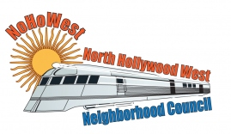  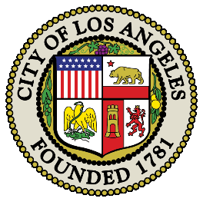 | BOARD MEMBERS  Alessandra Taryn Bea  Vickie Corona  John Dinkjian  Jim Kompare  Gabriel Ramos  Charles Savinar

NORTH HOLLYWOOD WEST NEIGHBORHOOD COUNCIL MINUTES
Special Board Meeting Minutes
Thursday, October 20, 2022
6:30pm
Zoom Meeting

 | Topic
1 | Call Meeting to Order – Roll Call – Welcome
 | The meeting was called to order at 6:38pm by President Greg Wright.
7 Present: Greg Wright, Carol Rose, Leslie Myrick, Lorraine Matza, Jim Kompare, Vicky Corona, Alessandra Taryn Bea
3 Absent: John Dinkjian, Jonathan Rogers, Charles Savinar

2 | Public Comments on Non-Agendized Items
 | There were no Public Comments.
3 | Discussion and Possible Action: to approve spending an amount not to exceed $1,500 on the City of Los Angeles Department of Recreation and Parks Spooky Spectacular at Valley Plaza Rec. Center on October 29, 2022, 2-7pm.
Leslie Myrick brought a motion to approve spending an amount not to exceed $1,500 on the City of Los Angeles Department of Recreation and Parks Spooky Spectacular at Valley Plaza Rec. Center on October 29, 2022, 2-7pm., seconded by Lorraine Matza
7 Ayes: Greg Wright, Carol Rose, Leslie Myrick, Lorraine Matza, Jim Kompare, Vicky Corona, Alessandra Taryn Bea
Vote: (7-0-0) Motion Passed

4 | Next NoHo West Neighborhood Council General Board Meeting will be on October 12, 2022 at 6:30pm
5 | ADJOURMENT
 | Meeting Adjourned

