EXECUTIVE COMMITTEE  Greg Wright  President  Carol Rose  Vice President  Lorraine Matza  Secretary  Leslie Ann Myrick-Rose  Treasurer | 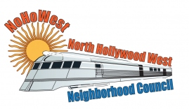  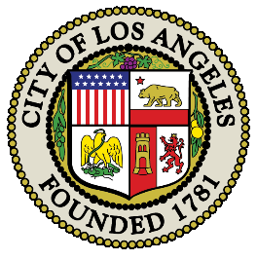 | BOARD MEMBERS  Alessandra Taryn Bea  Vickie Corona  John Dinkjian  Jim Kompare  Gabriel Ramos  Charles Savinar

NORTH HOLLYWOOD WEST NEIGHBORHOOD COUNCIL MINUTES
Special General Board Meeting Minutes
Wednesday, March 11, 2022
3:00pm
Zoom Meeting

 | Topic
1 | Call Meeting to Order – Roll Call – Welcome
 | The meeting was called to order.
7 Present: Greg Wright, Carol Rose, Jim Kompare, Lorraine Matza, Leslie Myrick,
John Dinkjian, Alessandra Taryn Bea
3 Absent: Vicky Corona, Gabriel Ramos, Charles Savinar
2 | Public Comment on Non-Agendized Items:
 | There were no Public Comments on Non-Agendized Items.
3 | DISCUSSION AND POSSIBLE ACTION: to approve holding an Easter Egg Hunt at Valley Plaza Rec Center on Saturday, April 16 at a cost not to exceed $800
Lorraine Matza brought a motion to approve holding an Easter Egg Hunt at Valley Plaza Rec Center on Saturday, April 16 at a cost not to exceed $800, seconded by Jim Kompare
7 Ayes: Greg Wright, Carol Rose, Jim Kompare, Lorraine Matza, Leslie Myrick,
John Dinkjian, Alessandra Taryn Bea
Vote: (7-0-0) Motion Passed

4 | ADJOURMENT
 | Meeting Adjourned

