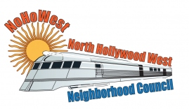 | North Hollywood West Neighborhood Council | 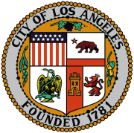
Executive Board  Greg Wright  President  Carol Rose  Vice President  Lorraine Matza  Secretary  Leslie Ann Myrick-Rose  Treasurer |  | Board Members  Alessandra Taryn Bea  Vickie Corona  John Dinkjian  James Kompare  Jonathan Rogers  Charles Savinar

Community Impact Statement
Council File 23-0002-S31
Catalytic Converter / Theft and Resale

March 8, 2023
The North Hollywood West Neighborhood Council supports CF 23-0002-S31 requesting that the City of Los Angeles include in its 2023-2024 Federal Legislative Program SUPPORT for legislation similar to S. 2024, the Preventing Auto Recycling Thefts (PART) Act.

