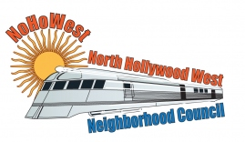 | North Hollywood West Neighborhood Council | 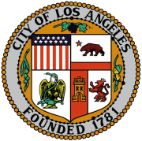
Executive Board  Greg Wright  President  Carol Rose  Vice President  Lorraine Matza  Secretary  Leslie Ann Myrick-Rose  Treasurer |  | Board Members  Alessandra Taryn Bea  Vickie Corona  John Dinkjian  James Kompare  Jonathan Rogers  Charles Savinar

Community Impact Statement
Council File 23-0002-S31
Prohibit Sale of Vehicles Without Catalytic Converter /
Etched Engraved Vehicle Identification Number

March 8, 2023
The North Hollywood West Neighborhood Council supports 23-0002-S29 requesting
that the City of Los Angeles include in its 2023-2024 State Legislative Program
SUPPORT for SB 55, which would prohibit the sale of vehicles without an
etched or engraved vehicle identification number on the catalytic converter.

