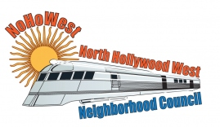 | North Hollywood West Neighborhood Council | 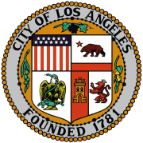
Executive Board  Greg Wright  President  Carol Rose  Vice President  Lorraine Matza  Secretary  Leslie Ann Myrick-Rose  Treasurer |  | Board Members  Alessandra Taryn Bea  Vickie Corona  John Dinkjian  James Kompare  Jonathan Rogers  Charles Savinar
Community Impact Statement
Council File 22-1070
Neighborhood Council Meetings / EmpowerLA Virtual Governance (EVG) System / In-Person / Emergency Declarations

February 15, 2023
The North Hollywood West Neighborhood Council supports CF 22-1070 to assess if individual Neighborhood Councils may be granted the flexibility to select a preferred meeting option going forward (virtual meetings, in-person meetings, or a hybrid meeting option). North Hollywood West Neighborhood Council recommends City Council and the Department of Neighborhood Empowerment authorize Neighborhood Councils to return to in-person meetings with or without a virtual meeting option.

