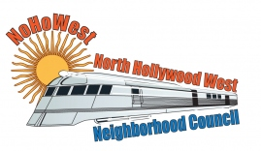 | North Hollywood West Neighborhood Council | 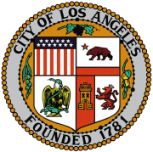
Executive Board  Greg Wright  President  Carol Rose  Vice President  Lorraine Matza  Secretary  Leslie Ann Myrick-Rose  Treasurer |  | Board Members  Alessandra Taryn Bea  Vickie Corona  John Dinkjian  James Kompare  Jonathan Rogers  Charles Savinar
Community Impact Statement
Council File 22-1196
Charter Reform Ballot Initiative / 2024 / Redistricting Process / Los Angeles City Council Seats / Representation Fixed to Population Growth

February 15, 2023
The North Hollywood West Neighborhood Council supports CF 22-1196 to instruct the Chief Legislative Analyst, with the Assistance of the City Attorney, to report on the steps needed to place a charter reform ballot initiative before the voters of Los Angeles in 2024, with recommendations that ensure representation is fixed to population growth, in order to increase the number of Los Angeles City Council seats, and further to prepare a report that outlines and sets forth an immediate redistricting process to implement the updated reforms, after passage of the above-mentioned charter reform ballot initiative.

