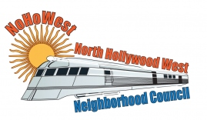 | North Hollywood West Neighborhood Council | 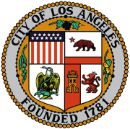
Executive Board  Greg Wright  President  Carol Rose  Vice President  Lorraine Matza  Secretary  Leslie Ann Myrick-Rose  Treasurer |  | Board Members  Alessandra Taryn Bea  Vickie Corona  John Dinkjian  James Kompare  Jonathan Rogers  Charles Savinar
Community Impact Statement
Council File 23-0038
Measure ULA / United to House LA / 2021-2029 Housing Element / Implementation

February 15, 2023
The North Hollywood West Neighborhood Council supports CF 23-0038 to instruct the Los Angeles Housing Department, with assistance from the City Administrative Officer, the City Attorney’s Office, the Department of Finance, and any other relevant departments, to report back within 15 days on the implementation of Measure ULA (United to House LA), including a plan for the expenditure of up to $500,000 (as detailed in Measure ULA and to be paid back in full from future Measure ULA revenue) to establish the House LA Fund and House LA Program, and to identify within 15 days any existing City, County, State, or federal funds—including the City’s General Fund and Reserve Fund— that could be utilized to effectively and expeditiously support rent relief, homelessness prevention, and affordable housing programs prior to Measure ULA revenue becoming available.

