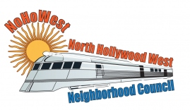 | North Hollywood West Neighborhood Council | 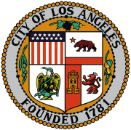
Executive Board  Greg Wright  President  Carol Rose  Vice President  Lorraine Matza  Secretary  Leslie Ann Myrick-Rose  Treasurer |  | Board Members  Alessandra Taryn Bea  Vickie Corona  John Dinkjian  James Kompare  Jonathan Rogers  Charles Savinar
Community Impact Statement
Council File 23-0056
Mental Evaluation Unit (MEU) / Domestic Abuse Response Team (DART) / Los Angeles Police Department / Capacity and Response Times

February 15, 2023
The North Hollywood West Neighborhood Council supports CF 23-0056 to instruct the City Administrative Office (CAO) and the Chief Legislative Analyst (CLA), with input from LAPD and all necessary departments, to report back within 30 days on the volume of mental health and domestic violence calls and incidents that occur annually within the city, as well as the capacity and response times that the current Mental Evaluation Unit (MEU) and Domestic Abuse Response Team (DART) resources can deploy along with a budget proposal for expansion of the MEU and DART, which should include the personnel, financial resources, and deployment procedures needed to make the programs more widely available in response to mental health emergencies.

