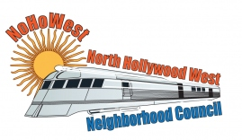 | North Hollywood West Neighborhood Council | 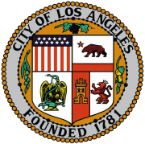
Executive Officers  Greg Wright  President  Carol Rose  Vice President  Leslie Ann Myrick-Rose  Treasurer  Secretary |  | Board Members  Vicki Corona  John Dinkjian  Holli Johnson  Jim Kompare  Adriana Gomez  Jonathan Rogers  Charles Savinar
Community Impact Statement
Council File 23-0867
FireWorks Buyback Program / LAPD Bureaus / 4th of July / Expansion

September 13, 2023
The North Hollywood West Neighborhood Council supports CF 23-0867 to instruct the Police Department (LAPD), with the assistance of the Fire Department, City Administrative Officer and the Chief Legislative Analyst to report to Council on resources required and potential funding sources for operating the Fireworks Buyback Program in every LAPD Bureau for the 4th of July holiday, as well as with a plan to expand the Program to include more locations and other firework heavy holidays.
Fireworks continue to be a significant issue reducing the quality of life for all residents. In North Hollywood West, our veteran stakeholders as especially negatively affected, as well as those suffering from PTSD and our pets.

