EXECUTIVE COMMITTEE  Greg Wright  President  Carol Rose  Vice President  Secretary  Leslie Ann Myrick-Rose  Treasurer | 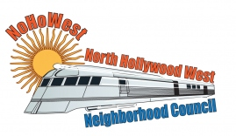  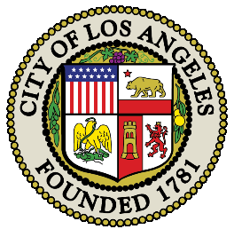 | BOARD MEMBERS  Vicki Corona  John Dinkjian  Adriana Gomez  Holli Johnson  Jim Kompare  Lorraine Matza  Jonathan Rogers  Charles Savinar

NORTH HOLLYWOOD WEST NEIGHBORHOOD COUNCIL MINUTES
Special Board Meeting Minutes
Saturday, November 8, 2023
2-5pm

 | Topic
1 | Roll Call – Welcome
 | The meeting was called to order at 2:30pm by President Greg Wright.
2 | ROLL CALL  8 Present: Greg Wright, Carol Rose, Leslie Myrick, Lorraine Matza, Jim Compare, Vicki Corona, Holli Johnson, Adriana Gomez  3 Absent: John Dinkjian, Jonathan Rogers, Charles Savinar
3 | PUBLIC COMMENT ON NON-AGENDIZED ITEMS
 | There were no comments on Non-Agendized Items
Motion to suspend the rules initiated by Lorraine Matza. Seconded by Holli Johnson.
Vote: (8-0-0) Motion Passed

 | Meeting was called back to order at 4:59pm.
4 | ADJOURMENT
 | Meeting Adjourned at 5:00pm

