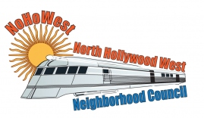 | North Hollywood West Neighborhood Council | 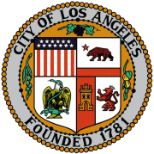
Executive Officers  Greg Wright  President  Carol Rose  Vice President  Leslie Ann Myrick-Rose  Treasurer  Lorraine Matza  Secretary |  | Board Members  Vicki Corona  John Dinkjian  Holli Johnson  Jim Kompare  Adriana Gomez  Jonathan Rogers  Charles Savinar
Community Impact Statement
NEIGHBORHOOD COUNCIL RESOLUTION

December 13, 2023
I, Greg Wright, declare that I am the President of the North Hollywood West Neighborhood Council (NC) and that on December 13, 2023, a Brown Act noticed public meeting was held by this NC with a quorum of __ (number) board members present and that by a vote of __ (number) yes, __ (number) no, and ___ (number) abstentions adopted the following resolution:

Whereas, this resolution is the official statement adopted by this Neighborhood Council. The NC satisfies the ⅔ board requirement of SB 411 and approves meeting virtually for board and committee meetings because it will provide increased accessibility and community engagement.

