EXECUTIVE COMMITTEE  Greg Wright  President  Carol Rose  Vice President  Lorraine Matza  Secretary  Leslie Ann Myrick-Rose  Treasurer | 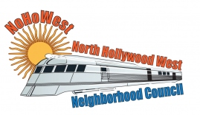  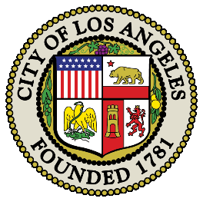 | BOARD MEMBERS  Vicki Corona  John Dinkjian  Adriana Gomez  Holli Johnson  Jim Kompare  Jonathan Rogers  Charles Savinar

NORTH HOLLYWOOD WEST NEIGHBORHOOD COUNCIL
Special Board Meeting Minutes
Tuesday, February 6, 2024
6:30 - 9:30 pm

 | Topic
1 | CALLMEETING TO ORDER – WELCOME
 | The meeting was called to order at 6:30 P.M. by President Greg Wright.
2 | ROLL CALL
8 Present: Greg Wright, Carol Rose, Leslie Myrick, Lorraine Matza, John Dinkjian, Adriana Gomez, Jonathan Rogers, Charles Savinar
3 Excused: Jim Kompare, Vicki Corona, Holli Johnson

3 | PUBLIC COMMENT ON NON-AGENDIZED ITEMS
Jason - The local alliance in North Hollywood needs help via volunteers.

Carla Montez - Greater Valley Glen NC – Carla thanked all the candidates for being present.

Matthew Fine – He thanked the candidates for being present, and discussed trespassing in abandoned buildings.
CITY LOS ANGELES, MEMBER OF THE CITY COUNCL, DICTRICT NO. 2, CANDIDATE FORUM:
- Opening Statement
- Issue Statements
- Closing Statement
- Homelessness
- City Services and Enforcement
- Public Safety and Crime
- Economic Development and Business Support
- Ethics and Governance
- Environmental and Quality of Life Issues

CLOSING STATEMENT

I. | OPENING STATEMENT  The following candidates introduced themselves:  - Jillian Burgos  - Sam Kbushyan  - Rudy Melendez  - Jon-Paul Bird  - Adrin Nazarian  - Manny Gonez
II | ISSUE STATEMENT  The following candidates gave an Issue Statement  1. Jillian Burgos  - Sam Bushman  - Rudy Melendez  4. Jon-Paul Bird  5. Adrin Nazarian  6. Manny Gonez
The following candidates addressed the following:
- Homelessness
- City Services and Enforcement
- Public Safety and Crime
- Economic Development and Business Support
- Ethics and Governance
- Environmental and Quality o Life Issues
1. Jillian Burgos
2 Sam Kbushyan
3. Rudy Melendez
4. Jon-Paul Bird
5. Adrin Nazarian
6. Manny Gonez

III. | CLOSING STATEMENT  The following candidates gave a closing statement.  1. Jillian Burgos  2 Sam Kbushyan  3. Rudy Melendez  4. Jon-Paul Bird  5. Adrin Nazarian  6. Manny Gonez
 | ADJOURNMENT
 | Meeting Adjourned

