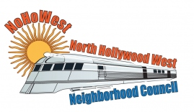 | North Hollywood West Neighborhood Council | 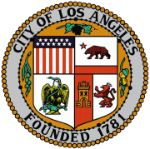
Executive Board  Greg Wright  President  Carol Rose  Vice President  Lorraine Matza  Secretary  Leslie Ann Myrick-Rose  Treasurer |  | Board Members  Vicki Corona  John Dinkjian  Adriana Gomez  Jim Kompare  Jonathan Rogers  Charles Savinar
Community Impact Statement
Council File 24-1344
Fee Waived / Adoptions and Redemption / Dogs / Cats / Rabbits / Prevent Animal Surrender / Promote Adoption

November 13, 2024
The North Hollywood West Neighborhood Council supports CF 24-1344 (Fee Waived / Adoptions and Redemption / Dogs / Cats / Rabbits / Prevent Animal Surrender / Promote Adoption) which includes establishing an ordinance allowing for the General Manager of the Los Angeles Animal Services Department to reduce or waive adoption and redemption fees for dogs, cats, rabbits, and other animals, to prevent the surrender of animals pursuant to guidelines established by the Board of Animal Services Commissioners and/or to encourage and promote adoptions.

