North Hollywood West Neighborhood Council
Governing Board
Greg Wright, President
John Dinkjian, Vice-President
Lorraine Matza, Secretary
Carol Rose, Treasurer
Vicki Corona, Board Member
Tim Glick, Board Member
Leslie Ann Myrick-Rose, Board Member
Jonathan Rogers, Board Member
Jennifer Rozo, Board Member
Charles Savinar, Board Member
CITY OF LOS ANGELES
CALIFORNIA

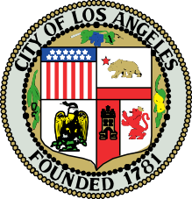
NORTH HOLLYWOOD WEST NEIGHBORHOOD COUNCIL

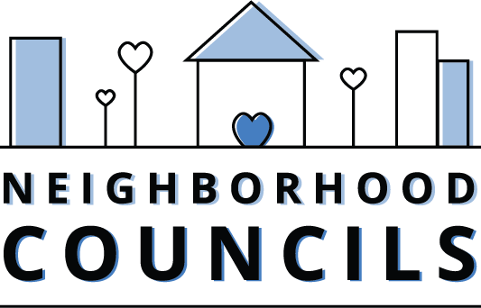

200 N. Spring Street
Los Angeles, CA 90012

Email: NCsupport@lacity.org
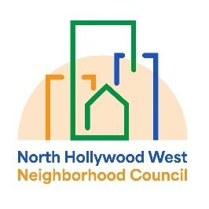
Website: www.empowerla.org

Community Impact Statement
Council File 25-0002-S113
Sideshow Accountability and Community Safety Act

June XX, 2026

The North Hollywood West Neighborhood Council supports Council File 25-0002-S113 to enhance penalties for engaging in, aiding, or abetting a motor vehicle exhibition of speed as part of a sideshow (aka a street takeover). It also seeks to strengthen enforcement tools available to local jurisdictions to address these activities by revising the definition of sideshow to include the use or operation of any motor vehicle, including, but not limited to, motorcycles or off-highway motorcycles to barricade, block, impede, or obstruct traffic.

Our neighborhood suffers from sideshows on a regular basis. We strongly support any additional penalties and tools for law enforcement to discourage these activities. Street takeovers create immediate dangers for drivers, passengers, pedestrians, bicyclists, and nearby residents because intersections are intentionally blocked, visibility is reduced, and emergency vehicles can be delayed when seconds matter most. They also impose a serious nuisance on the community through excessive noise, tire smoke, property damage, traffic disruption, and the diversion of police and city resources away from other pressing public safety needs. These events undermine residents’ sense of safety and interfere with the normal use of neighborhood streets by families, workers, transit users, and local businesses.

