North Hollywood West Neighborhood Council
Governing Board
Greg Wright, President
John Dinkjian, Vice-President
Lorraine Matza, Secretary
Carol Rose, Treasurer
Vicki Corona, Board Member
Tim Glick, Board Member
Leslie Ann Myrick-Rose, Board Member
Jonathan Rogers, Board Member
Jennifer Rozo, Board Member
Charles Savinar, Board Member
CITY OF LOS ANGELES
CALIFORNIA

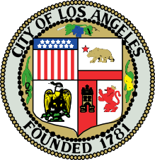
NORTH HOLLYWOOD WEST NEIGHBORHOOD COUNCIL

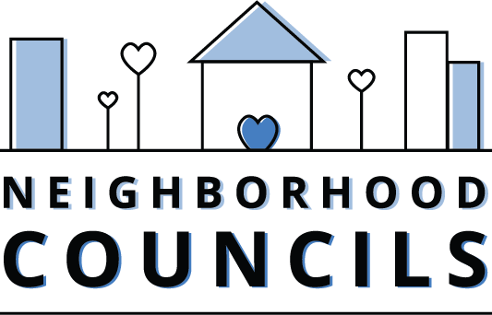

200 N. Spring Street
Los Angeles, CA 90012

Email: NCsupport@lacity.org
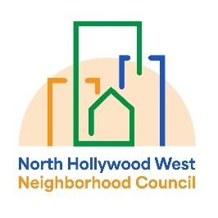
Website: www.empowerla.org

Community Impact Statement
Council File 25-0002-S116
Animal Cruelty Offenses / Forfeiture of a Seized or Impounded Animal

June XX, 2026

The North Hollywood West Neighborhood Council supports Council File 25-0002-S116 to establish procedures authorizing a court, in a criminal case alleging specified animal cruelty offenses, to order forfeiture of a seized or impounded animal before final disposition of the criminal case, 30 days after the defendant fails to appear in court.

We support the prompt rescue and protection of animals from abusive, neglectful, or dangerous situations so they can be removed from harm and placed in safe care as quickly as possible. Allowing these animals to remain in the custody of their abusers while legal proceedings continue can prolong suffering and place their health and welfare at further risk. A victimized animal should not be forced to stay with an abusive owner simply because that owner skirts showing up to court.

