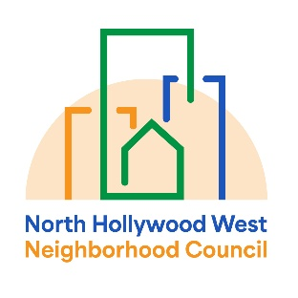 | North Hollywood West Neighborhood Council | 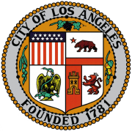
Executive Committee  Greg Wright  President  John Dinkjian  Vice President  Lorraine Matza  Secretary  Carol Rose  Treasurer |  | Board Members  Vicki Corona  John Dinkjian  Tim Glick  Lorraine Matza  Leslie Ann Myrick-Rose  Jonathan Rogers  Carol Rose  Jennifer Rozo  Charles Savinar  Greg Wright
General Board Meeting Minutes
Wednesday, February 11, 2026
6:30 PM – 7:02 PM
Location: Zoom Meeting Online or By Telephone

AGENDA ITEM | DETAILS
1. CALL TO ORDER | The meeting was called to order by President Greg Wright at 6:30 PM. A quorum of board members was established.
2. ROLL CALL | Present: Greg Wright, John Dinkjian, Lorraine Matza, Vicki Corona, Leslie Ann Myrick-Rose, Jonathan Rogers, Carol Rose, Charles Savinar, Jennifer Rozo (6:37 PM), Tim Glick (6:39 PM).  Absent: None.
3. PUBLIC COMMENT ON NON-AGENDIZED ITEMS | Rudy Melendez: Introduced himself as a candidate for Congressional District 29 and expressed appreciation for the neighborhood council system.  Lionel Mares: Reported on the adjournment of the City Charter Reform Commission meeting and urged advocacy for city services, ethics reform, and equitable resource distribution for the Valley.
4. REPORTS AND ANNOUNCEMENTS | LA City Council District 2 (Abkar Kalantarians):  * Announced a free senior self-defense class at Valley Plaza this Friday, 10:30 AM–12:30 PM.  * Reported on an upcoming safety audit with Metrolink regarding North Hollywood rail crossings following recent fatalities.  * Noted a tentative date of March 28 for a community cleanup.  Assemblywoman Rodriguez’s Office (Nayeli Garcia):  * Introduced herself as the new field representative for NoHo West.  * Announced a "Know Your Rights" door-hanger event ("Spread Love, Not Hate in the 818") on Valentine's Day.  * Provided a legislative update regarding the February 20 deadline for the office's bill package.
5. ADMINISTRATIVE MOTIONS | A. Minutes Approval: Motion to approve the January 14, 2026, minutes with a spelling correction for "WITC."  Moved: John Dinkjian; Seconded: Lorraine Matza.  Vote: Passed unanimously.  B. MER Approval: Postponed to the next meeting as the report could not be generated in time.
6. FUNDING MOTIONS | A. Lost Receipt Affidavit: Motion to approve an affidavit from Carol Rose for a $7.67 lemonade purchase for the January 14 meeting.  Moved: John Dinkjian; Seconded: Lorraine Matza.  Vote: Passed unanimously.  B. FurFest 2026: Motion to approve holding FurFest on Saturday, May 9, at Valley Plaza Recreation Center, at a cost not to exceed $4,000.  Moved: Carol Rose; Seconded: Lorraine Matza.  Vote: Passed unanimously.
7. NEW BUSINESS | Bylaw Amendment: Motion to add the phrase "each an officer" to the description of Board officers in Article VI, Section 1.  Moved: Lorraine Matza; Seconded: Jonathan Rogers.  Vote: Passed unanimously.
8. COMMITTEE & BOARD REPORTS | Outreach/Homelessness (John Dinkjian): Noted that the neighborhood is looking better and will provide updates on upcoming homelessness committee activities.  Land Use (Tim Glick): Reported a potential beer/wine license application for a new cafe at a former restaurant site; recommended a future Planning Committee meeting.  Bylaws (Lorraine Matza): Will coordinate with the Department of Neighborhood Empowerment (DONE) regarding the recently passed amendments.  President (Greg Wright): Mentioned receiving Neighborhood Purpose Grant (NPG) applications from the Insight Center and Comfy Care Packs.
9. ADJOURNMENT | The meeting was adjourned at 7:02 PM.

