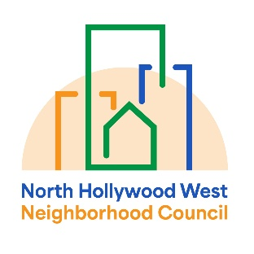 | North Hollywood West Neighborhood Council | 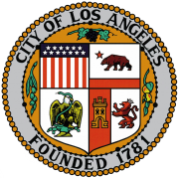
Executive Committee  Greg Wright  President  John Dinkjian  Vice President  Lorraine Matza  Secretary  Carol Rose  Treasurer |  | Board Members  Vicki Corona  John Dinkjian  Tim Glick  Lorraine Matza  Leslie Ann Myrick-Rose  Jonathan Rogers  Carol Rose  Jennifer Rozo  Charles Savinar  Greg Wright
General Board Meeting Minutes
Wednesday, April 8, 2026
6:44 PM – 7:52 PM
Location: Valley Plaza Branch Library; Zoom Meeting Online or By Telephone

1. CALL TO ORDER & ROLL CALL | The meeting was called to order by President Greg Wright at 6:44 PM once a quorum was established.  Present (In-Person): Greg Wright, Lorraine Matza, Tim Glick, Jonathan Rogers, and Charles Savinar.  Present (Remote): Jennifer Rozo (work-related), Leslie Ann Myrick-Rose (medical-related), and Carol Rose (medical-related).  Absent: John Dinkjian, Vicki Corona.
2. PUBLIC COMMENT ON NON-AGENDIZED ITEMS | No public comments were made.
3. REPORTS AND ANNOUNCEMENTS | LAPD: SLO Perez reported on homelessness and parking enforcement coordination with the DOT.  LA City Council District 2 (Abkar Kalantarians): Reported on the successful cleanup held on March 28. Announced CarePlus cleanups scheduled for April 20 to address public right-of-way issues. Updates were provided on the demolition of nuisance properties at 7722 Teesdale Ave. and 7779 Varna Ave. Discussion continues with academic experts regarding the future use of Strathern Park West.  Neighborhood Empowerment Advocate (Jose Galdamez): Provided the following deadline reminders:  - April 24, 2026: Deadline for youth (ages 14–17) to register for the EmpowerLA Youth Conference.  - May 1, 2026: Final deadline for Neighborhood Council Bylaw amendment submissions.  - May 20, 2026: Final deadline to submit Neighborhood Purpose Grants (NPG) for the current fiscal year.  - June 1, 2026: Final deadline for all check payment and credit card (PCard) transactions for the fiscal year.  State Government: Nayeli Garcia (Assemblymember Rodriguez’s Office) reported on health legislation and announced an Emergency Awareness Workshop (April 11) and a Caltrans cleanup (April 24).  Mayor’s Office: Betsaira Aguilera detailed an immigration enforcement town hall and a streetlight repair initiative. Announced a resource fair at LA Mission College on April 23.  LAFD Battalion 14: Chief Dixon reported 948 total incidents for Station 89.
[TECHNICAL NOTE]: At 7:12 PM, the library location lost internet connectivity, pausing the meeting. The meeting reconnected at 7:21 PM.

4. EXECUTIVE OFFICER REPORTS | President: Greg Wright discussed filling vacant board seats, specifically the Community-Based Organization, Business Representative, and Senior/Youth seats.
5. ADMINISTRATIVE MOTIONS | A. Approval of March 11, 2026 Minutes:  - Moved: Charles Savinar; Seconded: Jonathan Rogers.  - Vote: Passed (8 Ayes, 0 Nays, 0 Abstentions).  B. Approval of March 2026 MER:  - Moved: Jonathan Rogers; Seconded: Tim Glick.  - Vote: Passed (8 Ayes, 0 Nays, 0 Abstentions).  C. Zoom License Renewal: Approved $255.61 for the annual license renewal.  - Moved: Lorraine Matza; Seconded: Tim Glick.  - Vote: Passed (8 Ayes, 0 Nays, 0 Abstentions).
6. PLANNING & LAND USE MANAGEMENT | Blackjack Market CUB Application: Review request for a letter of support for an expanded liquor license and a 27-seat patio cafe.  - Moved: Jonathan Rogers; Seconded: Carol Rose.  - Vote: Passed (8 Ayes, 0 Nays, 0 Abstentions).
7. ADJOURNMENT | The meeting was adjourned at 7:52 PM. Next meeting: May 13, 2026.

